Regular exercise during pregnancy can lead to shorter labors, less pain, and less exhaustion. All of the exercises listed are safe and encouraged for pregnancy; if, however, you experience pain or discomfort during any of these exercises, consult your doctor or midwife.

- The Kneeling Superman

Why?
Labor and birth is hard work; this exercise gently strengthens your abdominals, back muscles, arms, and legs without putting strain on the lower back, especially when care is taken to stabilize your body as much as possible. This exercise is a good warm-up before engaging in other exercises.

How?
- Start in an all fours position with the wrists under the shoulders and the knees under the hips.
- Exhale, suck in your belly towards your spine, keeping your back flat like a tabletop.
- Send one leg back, pressing the feet against an imaginary wall.
- As much as possible, keep the raised foot perpendicular to the floor to keep the hips level.
  - The heel and back of the ankle should be facing the ceiling.
- Once you are stable in this position, raise up the opposite hand straight out as if you were shaking hands with everyone.
- Keep shoulders relaxed and pressed away from the head.
- Lower arms and legs; repeat
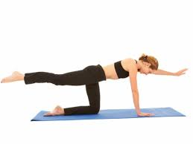
Modifications:
- If pelvic alignment and engagement abdominal muscles cannot be maintained throughout the open and close movement, eliminate it and just hold the balance.
- This can be done just lifting the leg or just the arm.
For a video demonstration, search on Youtube for the “Pilates Workout Exercise: Watchdog” video by Ultimate Pilates Workouts Online

2. Super Kegels
It’s basically just a kegel but held for as long as possible!

3. Squatting and the Garland Pose

Why?
Squatting is a position commonly used in labor. It is helpful as a laboring stance because it puts light pressure on the pelvic floor and maximizes the work of gravity to assist the baby’s descent. However, it is a tiring position to be in if not practiced beforehand. Regularly practicing this exercise strengthens legs, glutes, and back muscles.
Women often tense their inner thigh and pelvic floor muscles in the day-to-day, so it’s helpful to practice relaxing and stretching them by squatting during pregnancy to prepare for birth.

How?
- Stand with your back straight and shoulders down, with your feet a little more than shoulder-width apart and your toes turned inward.
- Bend your knees, slowly, and make sure you keep your back straight and upright as you descend.
- Keeping your knees apart as far as is comfortable, slowly lower down until your body tells you to stop.
- Stay here for a few seconds and take one deep breath.
- Slowly stand back up, keeping your back straight, using your legs and glutes to raise you up.
For extra stability, hold on to some furniture, a birth ball, or a partner.

For a deeper inner-thigh stretch, squat as usual, and then let your tailbone drop down to the floor. Hold on to a birth ball, or press your palms together as if to pray with your elbows in front of your lets. This is called the garland pose.
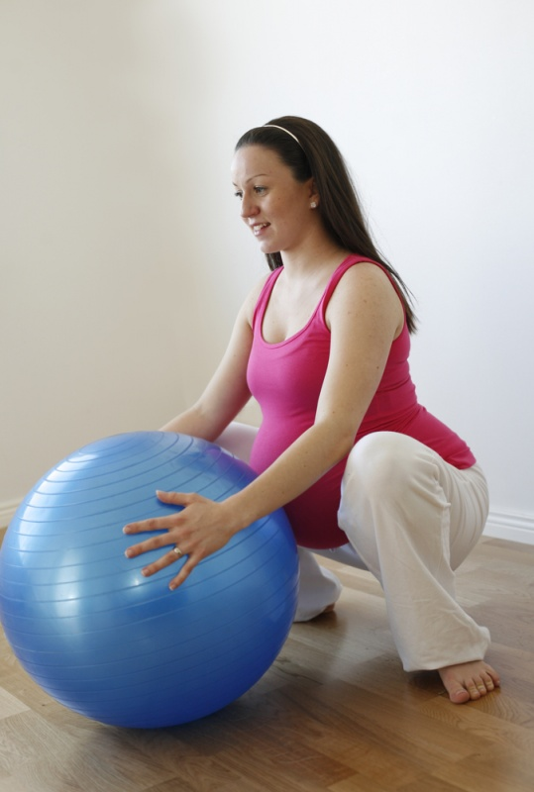
4. Lying-down leg raises

Why?
Back pain is a common problem during pregnancy. One of the best ways to treat mild back pain is practicing core-strengthening and stabilizing exercises. Having stronger core muscles means that your back muscles need to do less work throughout the day to keep you upright and stable.

How?
- Start in a lying-down position on a flat, hard surface (not a bed!)
- Place your hands either on your lower stomach or out to the sides.
- Suck in your stomach, gently pulling your navel towards your spine.
- Slowly raise your right leg as high as feels comfortable, and use your abdominal muscles to keep your body still.
- Remember to breathe deeply - it’s easy to get tense! If you are new to this exercise, some involuntary trembling may occur.
- Slowly lower your right leg back down.
  - Your back will want to arch, but use your abdominal muscles to keep your spine pressed flat to the floor or mat. This is the hardest part!
- Repeat on the left side.
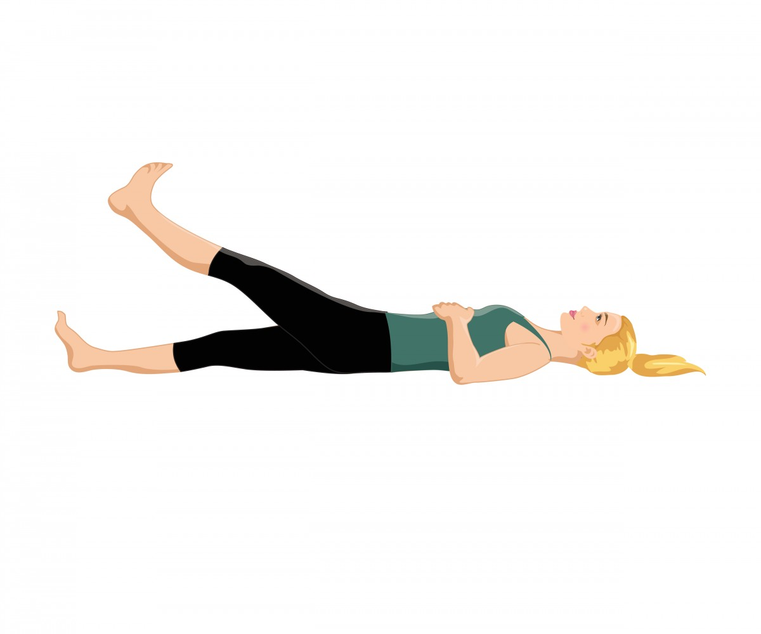

For an extra challenge, try raising both legs at the same time.
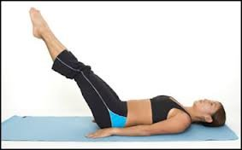

For an extra extra challenge and an inner-thigh workout, try raising both legs at the same time with a light object like an exercise ball or a small pillow between your knees or feet. Squeeze the object while you raise and lower your legs to work out your inner thighs.
5. Pelvic Tilt/pelvic rock on hands and knees

Why?
Hands and knees is another popular laboring position. It can be very relaxing to get in a hands and knees position and rock back and forth on an exercise ball. This can be done on a bed or on the floor.
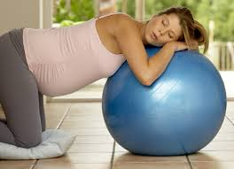
The pelvic tilt exercise stretches the lower back, upper back, and shoulders and can promote relaxation when done slowly and mindfully.
During late pregnancy, pressure on the bladder from the baby’s head can cause frustrating urinary frequency. This slow exercise encourages the baby to move up slightly, relieving some pressure from the bladder and relieving some lower back pressure.

How?
- Get on your hands and knees, ensuring that your hands are under your shoulders and your knees are under your pelvis.
- Take a moment to make sure your shoulders are relaxed and pressed back and away from your head and neck.
- Slowly and carefully rock your pelvis so that your back arches up toward the sky.
- Breathe deeply and engage your abdominal muscles to maintain this position for a few seconds.
- Slowly, release back to a flat back position.
**do not arch the other way, dipping your back like a stretching cat. This is the other half of the practice but it is not recommended during pregnancy because it may increase back pain or strain uterine ligaments.
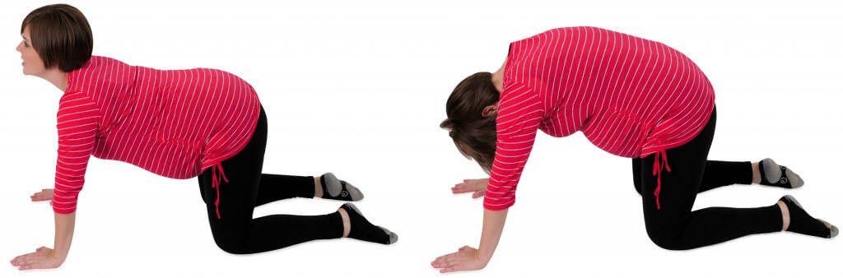

6. Perineal Massage

Why?
Perineal tearing is a common fear about giving birth. There is some evidence that gentle massage may make the perineum more pliable and less likely to tear. It is important not to do this exercise to the point of discomfort, because it may cause inflammation.

How?
Either the birth partner or the expectant mother can do the massage.
- Make sure your fingernails are short. Wash your hands before beginning. If you have rough skin on your fingers that might scratch her, wear disposable rubber gloves.
- Have the mother make herself comfortable in a semi-sitting position, with her legs bent and relaxed.
- Lubricate your index finger with lubricant or oil (may be vegetable, wheat-germ, or coconut). Do not use baby oil, mineral, or petroleum jelly, as they tend to try the tissue.
- Start with one index finger. Place your finger well inside the mother’s vagina, beyond your second knuckle. Bend your finger slightly, and pull down and out (in the same direction the baby will come out) until she tells you she feels a slight stinging. Give her time to relax to the stinging sensation. If she cannot, ease the pressure until the can relax.
- While maintaining the same pressure, slowly rotate your finger in a U-shaped curve to the left, back to center, and to the right, back and forth for three minutes. If you think of six o’clock as straight down, you’ll be moving from about four o’clock to about either o’clock. The mother should concentrate on relaxing her perineum as she feels the pressure.
- Once the mother gets used to massage with one finger, try using both index fingers at the same time, in opposite directions - from six to eight o’clock with your left finger, and from six to four o’clock with your right finger.
- As the mother becomes more comfortable with the massage, increase the pressure just enough to make the perineum begin to sting from the stretching.
- Ask your caregiver or your childbirth educator to answer any questions you may have after trying the massage.

For more information about perineal massage, see Penny Simpkin’s The Birth Partner

